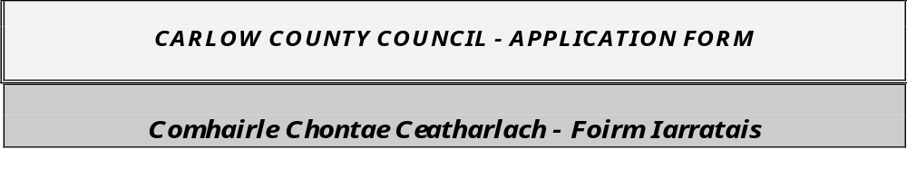

County Buildings,
Athy Road,
Carlow
R93 E7R7
Telephone: (059) 9170300 Fax: (059) 9141503

FOUR APPLICATION FORMS (one original completed signed copy and three full copies of the original) SHOULD BE RETURNED should be returned to the Administrative Officer, Human Resources Department, Carlow County Council, County Buildings, Athy Road, Carlow, R93 E7R7, not later than 12.00 noon, on Friday 30th October 2026. (Completed application form should be forwarded in sufficient time in order to ensure receipt by this deadline). Curriculum Vitae or applications by email or fax will NOT be accepted.

Panels for the post of
Temporary Relief/Substitute School Warden (Part Time)

Please indicate with an X which area(s) you wish to be considered for
Bagenalstown |  | Ballon
Carlow Town |  | Hacketstown
Tullow

PERSONAL DETAILS

1. Name in Full ______________________________________________________

2. Postal Address ______________________________________________________

Notify any change at once ______________________________________________________
in writing
______________________________________________________

3. Tel. Nos: __________________ ____________________ ____________________

[Home] [Work] [Mobile]

4. Email Address: ________________________________________________________________

5. Do you possess a full-unendorsed driving licence Yes No

6. Driving Licence Details: Driving Licence No: _____________________

7. Do you require a work permit/working authorisation visa Yes No

If answered yes to question 6 & question 7 above: Please submit copy of work permit/working authorisation visa and copy of driving licence with your application form.

WORK REFERENCES:

Give name, address, occupation, and email address for two responsible persons (not relatives) to whom you are personally known. Please include your current/most recent employer details.

- ____________________________________ 2. _____________________________________
______________________________________ ____________________________________
______________________________________ ____________________________________
Occupation: __________________________ Occupation: _________________________
Email: ________________________________ Email: ______________________________

Do you have any objection to Carlow County Council contacting your past/or present employers?

Yes No

Carlow County Council welcomes applications from disabled people and information about disability is only requested on the application form in order that appropriate arrangements for the aptitude test and /or interview can be made, if necessary.

Do you consider yourself disabled? __________________

Are you registered disabled? __________________

If you consider yourself disabled, please give details of any specific requirements you may need for interview arrangements:

_______________________________________________________________________________________

_______________________________________________________________________________________

_______________________________________________________________________________________

_______________________________________________________________________________________

_______________________________________________________________________________________

_______________________________________________________________________________________

EDUCATION / TRAINING

- Please list all educational and technical qualifications giving period with dates spent at each school/college and particulars of Certificates [if any] obtained.

Dates |  | School/College Attended | Examination | Year Taken
From | To

- Please list all training courses undertaken (either in-house or privately):

Dates |  | Organisation/Body | Course Title | Qualifications obtained
From | To
EMPLOYMENT RECORD

Remember you may be shortlisted based on the information you supply in the Application Form. Candidates are advised not to submit a Curriculum Vitae. Anything you write may be discussed in more depth, should you be called for an interview.

- Give below details of present position.

PRESENT POSITION

TITLE: _______________________________ FROM (date): ________________________________

EMPLOYER: ___________________________________________________________________________

MAIN RESPONSIBILITIES [in bullet point format]:
__________________________________________________________________________________________________________________________________________________________________________________________________________________________________________________________________________________________________________________________________________________________________________________________________________________________________________________________________________________________________________________________________________

2. Give below in date order full particulars of ALL other relevant employment or experience to date. Indicate clearly the type of experience, especially experience specified as essential or desirable in the qualifications for the post.
Dates |  |  | Name & Address of Employer | TITLE OF POST & DESCRIPTION OF DUTIES  Please indicate whether post is Permanent/  Temporary/Acting]
Period in Months | From | To | Name & Address of Employer

Any additional information you wish to give in support of your application.

What aspects of your career to date do you see as being most relevant to the position applied for?

If appointed, what is the earliest date you can take up duty.

AUTHORISATION & DECLARATION BY CANDIDATE
- I hereby authorise Carlow County Council if necessary to verify separately my educational qualifications with any of the Educational Institutions I attended.

- I hereby authorise Carlow County Council, if necessary, to make an Application for Garda Vetting.

- I solemnly declare that the replies to the questions written above by me to Carlow County Council are true and complete and I have not withheld any material fact. I note that any incorrect answer given by me, or the withholding of any material facts, may result in my not being considered for employment with Carlow County Council, or after employment, in my dismissal.

I, THE UNDERSIGNED, HEREBY SOLEMNLY DECLARE, ALL THE FOREGOING PARTICULARS TO BE TRUE

SIGNATURE OF APPLICANT: __________________________________

DATE: __________________________________

NOTE: FULLY COMPLETED APPLICATION FORM must be submitted. Curriculum Vitae or applications by email or fax will not be accepted.

- Before signing the above please ensure that you have replied fully to all questions and that you have included 4 copies of your application form. Carlow County Council may not be in a position to investigate the eligibility of all candidates in advance of the interview / examination, and hence persons who are ineligible but nevertheless enter may put themselves to unnecessary expense.

- In accordance with the principles of the General Data Protection Regulations, the information sought in relation to this recruitment campaign will not be used for any other purpose by Carlow County Council and will be destroyed following the expiry of any panel put in place in respect of this competition.

- If you wish to have your application form acknowledged, please enclose a stamped addressed envelope.

- Applications received after the closing date (12.00 noon, Friday 30th October 2026), will not be considered.

it should be clearly noted that canvassing on behalf of candidates will lead to their disqualification from the competition

CARLOW COUNTY COUNCIL IS AN EQUAL OPPORTUNITIES EMPLOYER

