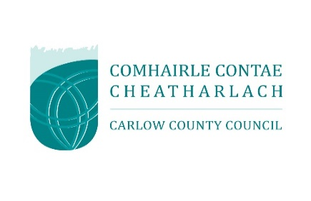

INTERMENT NOTICE
This form applies to all interments including new plots, existing plots, and cremations.
You can return it by post or email.
- Email: environment@carlowcoco.ie
- Post: The Environment Department, The Assembly Rooms, Cox’s Lane, Carlow R93 X35T

Personal Details of Deceased
Surname
First Name
Last Address
Eircode
Date of Birth |  | Date of Death
Religion (If Applicable)
Occupation

Interment Details
Cemetery Name/Location
Date of Interment
Funeral Director
Registrar

Grave Location
Section
Row
Plot No/s
Interment Register Number
Burial Type | Coffin |  | Urn

Payment Details for Deed and Invoicing of New Plots

Plot Size | Single Plot |  | Double Plot |  | Cremation Vault

The deed of the plot will be registered in this name and can be registered to one person only
Name of Purchaser /
Deed Holder
Name and Address for Invoice
(If different from above)
Please include Eircode
Cost of Cemetery Plot
St. Mary’s Cemetery Only
Cost of Opening Plot
Cost of Interment of Ashes
For Office Use Only
Plot Box Burial Record |  | Plot Box Deed |  | Invoice Issued |  | Ref: ENV
Record on Sale of Plots |  | Paid |  | Receipt No.
Signed: |  |  |  | Date:

