



Draft - Casual Trading Bye-Laws 2026 Municipal District of Carlow

Contents
Foreword 1
PART 1 1
Bye-Laws 2026 1
Citation 1
Commencement 1
Definitions 2
PART 2 4
General 4
Licence 6
Litter 7
Authorised Officers 8
Event Trading 9
Fees 9
Penalties 10
Variations 10
PART 3 11
Designation of Casual Trading Areas 11
Appendix 1 - Municipal District of Carlow – Trading Locations 12
Appendix 2 - Application Form …………………………………………………………………… 13
Application Form for a Casual Trading Licence ………………………………………………... 16
Appendix 3 – Casual Trading Licence …………………………………………………………… 20
Casual Trading Licence – County of Carlow ……………………………………………………. 20

CASUAL TRADING ACT 1995
Bye-laws in relation to the Control, Regulation, Supervision and Administration of Casual Trading
Carlow County Council

Foreword

It is the intention of this Bye-Law to allow that Carlow Municipal District will consider on an ongoing basis the issuing of licences to trade at several designated public outdoor areas listed as part of this document to the providers of mobile units for the sale of take away hot or cold beverages such as teas / coffees, juices, soft drinks, light refreshments (pastries, sandwiches), confectionery, ice creams or other items permitted under Licence from Carlow Municipal District. The selected areas has been designated due to their requirement for such facilities on a tourism and amenity basis.

PART 1

Bye-Laws 2026

The Council of the County of Carlow pursuant to the powers conferred on them by Section 6 of the Casual Trading Act 1995 as amended and Section 19 of the Local Government Act 2001 hereby makes the following Byelaws in relation to the control, regulation, supervision of Casual Trading for the Administrative and Functional area of the Carlow.

Citation

These Bye-laws may be cited as the “Casual Trading Bye-Laws 2026 for the Municipal District of Carlow”.

Commencement

These Byelaws shall come into operation on the 16th October 2026 or in the event of an appeal on the date of final confirmation by the District Court or Circuit Court whichever is applicable.

Definitions

In these Byelaws, the following definitions shall apply: -

“the Acts” | means the Casual Trading Act 1995 as amended, Local Government Act 2001 and Local Government Reform Act 2014
“the Council” | means the Council of the County of Carlow
“Municipal District of Carlow” | means the Functional Area comprising the Administrative Area of the Municipal District of Carlow”
“Casual Trading” | Has the meaning assigned to it in Section  2 of the Casual Trading Act 1995 as amended.
“Casual Trading Area” | Means the lands designated as an area, as per these bye-laws and Appendix 1 attached hereto, where casual trading may take place.
“Stall” | Shall include any wheeled or moveable stall or box, barrow, cart, trailer, caravan or other vehicle or both or other stand or conveyance used for casual trading.
“Goods” | shall include all provisions or marketable commodities.
“sell”, “Selling” or “sale” | Includes agreeing to offer to sell or displaying for sale or inviting an offer to buy.
“Licence” | Means licence under Section 4 of The Casual Trading Act, 1995 as amended and for the time being in force.
“Casual Trader/Licence Holder” | Means any person licensed to carry out casual trading pursuant to “the Acts” as amended and these bye-laws and shall include his/her servants or agents, if authorised in writing in accordance with these bye-laws.
“Trading Bay” | Means the maximum single area, as defined on the maps set out on the

 | Appendix 1 attached to these bye-laws, that may be occupied in a Casual Trading Area by a person engaged in casual trading.
“Vehicle” | Means and includes every means of conveyance, whether mechanically propelled or not, of persons, market produce or any goods or article.
"Authorised Officer" | Means a person appointed by the Local Authority under Section 10 of the Casual Trading Act 1995 as amended and Section 19 of the Local Government Act 2001.

PART 2

General

- Casual trading shall only be carried on at the locations designated for that purpose in Part 3 of these Bye-Laws or for a specified event or events at such other locations as may be approved by the Council in a licence issued pursuant to Section 4(1)(a)(iii) of the Act. Designated areas are indicated on the maps attached to Appendix 1 of these Bye-Laws.

- A person shall not engage in casual trading unless he/she holds a Casual Trading Licence from the Council that is for the time being in force and the casual trading is in accordance with the licence.

- No goods or articles shall overhang a stall or be deposited on the ground except within the trading place.

- Stalls and all other articles must be removed after the hours of trading specified in the licence.

- The Council reserves the right to remove stalls found on the casual trading area after trading hours and/or goods or other articles left outside the trading place at any time. These items will be stored by the Council and will only be returned to the licence holder on the payment of the Council's costs in relation to the administration, removal and storage of these items.

- Licence holders engaged in the sale of foodstuffs shall comply with the requirements of the Food Hygiene Regulations for the time being in force or any further regulations that may be made in that regard and applicants for a Casual Trading Licence relating to the sale of food must produce evidence of compliance with such regulations.

- A licence holder trading in a casual trading area shall not be permitted to use a loud speaker or public address system and shall refrain from causing nuisance or disturbance.

- Casual trading shall take place only during the hours specified in a casual trading licence. In the absence of being so specified between the hours of 8.00
a.m. and 6.00 p.m.

- Licence holders shall ensure that no obstruction is caused or allowed to be caused to the owners or occupiers of premises and their invitees in the vicinity of the Casual Trading area.

- No licence holder or any other person shall interfere with or obstruct any officer, servant or agent of the Council engaged in the carrying out of any works of maintenance on any part of the casual trading area even where such work is carried out during trading hours.

- The stall holder shall not display goods beyond the boundaries of his/her stall either on the ground or hanging over the sides of the stall, or deposit or cause to be deposited any goods or articles on the ground except on the portion of the ground within the trading bay.

- All generators used in conjunction with Casual Trading stalls, shall conform to acceptable noise levels and a manufacturer’s certificate will be required to confirm specification.

- The Council shall not be responsible for any property belonging to any person wherever deposited or left in any part of the casual trading area nor for any loss, damage or injury caused by the negligence of any licence holder, his agents, employers or customers.

- In the event of non-compliance with any of these regulations by the holder of a trading licence or by his/her servant or agent, Carlow County Council may terminate the trading licence without notice.

- These Bye-laws shall be known as the ”Municipal District of Carlow - Casual Trading Bye-Law 2026”.

- A person engaged in casual trading shall indemnify the Council against any claim whatsoever by any person for damages for personal injuries, loss or damage caused by any act or omission of the said person holding a licence or his/her servants or agents in and about the carrying on of casual trading.

- Applications for licences must be accompanied by evidence of a current valid policy of insurance with a recognised insurance company and covering all activities associated with the purposes for which the Casual Trading Licence is to issue including all risks and perils to a minimum of €6,350,000 for any one incident, extending to provide an indemnity to the Council in respect of claims arising from the negligence of the Trader. Notice of termination of a policy shall render the said Casual Trading Licence null, void and of no effect and in which event the licence holder including servants and agents of the applicant shall forthwith cease to trade and render the area vacant.

Licence

- (i) An application for a Casual Trading Licence shall be made not less than thirty days in advance of the first date on which trading is to take place.

  - Only goods listed on the licence application may be sold from the stall of a casual trading licence holder.
  - Casual trading shall be confined to the trading place at the designated Casual Trading Area in accordance with the licence issued and stalls are to be wholly within the trading places in the Casual Trading Area.
  - The type of stall must be approved by the Council.
  - The allocation of a trading location shall not confer upon the licence holder any tenancy or right to occupy or transfer said trading space/bay.

  - A casual trading licence for stall trading shall be effective for a period of one year subject to compliance by the Stall Trader with the Bye-Laws and subject to paragraph (viii) below.

  - A register of Casual Trading Licences shall be retained by Carlow County Council.

  - A Casual Trading Licence may be revoked at any time by the Municipal District at its discretion, as provided for in the Casual Trading Act 1995 as amended.

- An applicant for a casual trading licence shall pay a licence fee as set out in the schedule attached hereto.

- The Council may grant more than one casual trading licence in respect of one trading location within a Casual Trading Area.

- The Council reserves the right to include any condition, within reason, on a casual trading licence.

- The Council reserve the right to grant or refuse a Casual Trading Licence.

- A licence holder trading in a casual trading area shall display the Casual Trading licence number relating to the trading, in such a position as to be clearly visible and easily legible to members of the public.

- A Casual Trading Licence shall only be used by the person to whom the licence was issued or by such agent of such person as agreed in writing by the Council. The holder of a Casual Trading Licence shall be restricted to trading in the area, allocated for that specific licence.

- The Council may revoke a Casual Trading Licence if it is not satisfied that a condition of the licence is being or has been contravened or if the person to whom it was granted is convicted of an offence in relation to the importation, possession or sale of goods committed while he/she was the holder of a casual trading licence or an offence under the Act.

- If the trading area is not used for a continuous period by the licence holder, the Council may, at its discretion, serve notice on the licence holder that his/her licence may be revoked for the remainder of the licence period, and arrange to reallocate the bay in question.

Litter

- A person carrying on casual trading shall keep the area in which he/she is casual trading in a clean and tidy condition.

- A suitable receptacle for refuse, agreed with the Council, must be provided by the licence holder and must be kept at all times of trading within the trading area.

- Litter must not be allowed to accumulate in the vicinity of the trading area during casual trading hours and at the end of the trading the trading area must be cleaned up and all refuse removed and properly disposed of by the licence holder.

- Each trader shall be responsible for the management of all wastes arising from his/her trading and associated activities and shall remove all waste generated from his/her business or trade. All waste removed by traders from the Designated Casual Trading Area shall be disposed of in a manner which complies with the Waste Management Acts. Any trader found to be in breach of this bye-law shall be liable to prosecution under the Litter Pollution Acts and shall be liable to have their Casual Trading Licence revoked.

- Each trader who sells food or drink for immediate consumption shall comply with Section 15 of the Litter Pollution Act 1997 in that suitable waste receptacles shall be provided to prevent the creation of litter and the trader shall ensure that any litter caused by the operation of the outlet is removed from the vicinity within a reasonable distance of their trading area.

Authorised Officers

- The Council shall appoint Authorised Officers for the purposes of managing and controlling its Casual Trading Areas.

- An Authorised Officer may:

- enter, inspect, and examine any place where she/he has reasonable cause to believe casual trading is being engaged in.

- require any person whom she/he has reasonable cause to believe to be engaging in casual trading:-

to produce, if it is not being displayed, a casual trading licence authorising such trading and to permit the officer or member of the Garda Siochana to examine the licence, and

if she/he fails, neglects or refuses to produce such a licence or, in a case in which it is not being displayed, to furnish to the officer his/her name and address and, if she/he is the servant or agent of another person, the name and address of the other person,

- make such examination and inquiry as may be necessary to ascertain whether the provisions of this Act or of bye-laws made thereunder are being complied with,

- require any person whom he/she has reasonable cause to believe to be engaging in casual trading in contravention of this Act to give such information as is in his/her power to give as to the ownership of any goods being sold in the course of such trading.

- require any person whom he has reasonable cause to believe to be engaging in casual trading in contravention of these Bye-laws to produce to him any documents, books or records relating to such trading in his power, possession or control and give to him/her such information as he/she may request in relation to entries in those documents, books or records and examine, copy or take extracts from any such document, book or record.

- An authorised officer who proposes to perform a power or function conferred on him/her by paragraph 2. may request a member of the Garda Siochana to accompany her/him if he/she has reasonable cause to apprehend any obstruction in the execution of his/her duty.

- A person shall not obstruct or interfere with, or give false information to, an authorised officer or a member of the Garda Siochana in the performance of his/her functions under these Bye-laws.

- A person shall not fail, refuse or neglect to comply with a requirement of an Authorised Officer or a member of the Garda Siochana under these Bye-Laws.

- A person shall be deemed not to have failed or refused to comply with a requirement of an authorised officer under these Bye-laws to produce a casual trading licence if he gives to the officer his name and address and if he is the servant or agent of another person, the name and address of that other person.

Event Trading

- Carlow County Council reserves the right to award trading licences to traders for special events, festivals and fairs for the Municipal District of Carlow.

- Applications for an event trading licences shall be made not less than thirty days in advance of the date on which trading is to take place.

- The Council reserves the right to limit the number of licences awarded for each event.

- The Council reserves the right to allow trading to take place outside of the hours specified in Article 6(iii) for certain events.

- Trading shall be carried out in accordance with specific conditions attached to the event trading licence and all conditions of such licence shall be strictly adhered to by the licensee.

- All articles of these bye-laws shall apply to licensees licensed for event trading.

Fees

- The following are the fees in respect of Casual Trading Licences for the Municipal District of Carlow.

- An applicant for a Casual Trading Licence in a casual trading area shall pay a licence fee of €500 per annum except where casual trading takes place on more than one day per week then the licence fee shall be €500 plus €125 for each additional days casual trading per week. The maximum annual fee for a Casual Trading Licence will be €1,250 per Casual Trading Area. An applicant for a Casual Trading Licence to trade at locations specified in the licence for a specified event or events pursuant to Section 4(l)(a)(iii) of the Act shall pay a licence fee of
€50 per day. The fees set out under this section may be updated annually by the Council in accordance with the Consumer Price Index.

Penalties

- Every person who shall offend against any of the foregoing bye-laws (Section 3) shall be liable on conviction to a fine not exceeding €12,679 (Section 14) and €1,269 (other than Section 14) in accordance with the Casual Trading Act 1995 as amended or such increased amounts which may be fixed by statute from time to time.

Variations

- Carlow County Council may vary the location and number of trading bays referred to in Part 3 of these Bye Laws to reflect decisions that are taken in
the interest of the proper planning and development of the Municipal District of Carlow.

PART 3

Designation of Casual Trading Areas

The lands as set out below and as delineated on the maps attached hereto are hereby designated as the Casual Trading Areas by the Council for the County of Carlow. The number of trading places indicated below for each Casual Trading Area shall be the maximum number of trading places for that Casual Trading Area and the location of each trading place shall be as indicated on the maps attached hereto in Appendix 1.

Municipal District of Carlow
Town/Village | Location | General Area / No. of Trading Licences | Map attached Numbered
The Exchange | Carlow | 12 | 1
Graiguecullen | Carlow Town Park | 2 | 2
Painestown | Oak Park Forrest Park | 1 | 3
Kearnstown | Brownshill Dolmen | 1 | 4

These Bye-Laws shall be known as the “Municipal District of Carlow- Casual Trading Bye-Laws, 2026” and shall come into operation on the 16th of October 2026
Made and Adopted under the Common Seal of Carlow County Council for the County of Carlow this 8th Day of June 2026.

Signed: ____________________________
XXXXX
Mayor

_____________________________
XXXXX
Director of Service

Appendix 1 - Municipal District of Carlow – Trading Locations

Map Number | 1
Area | The Exchange
Specific Location | Carlow
Municipal District | Carlow
Max. Number of Licences | 2

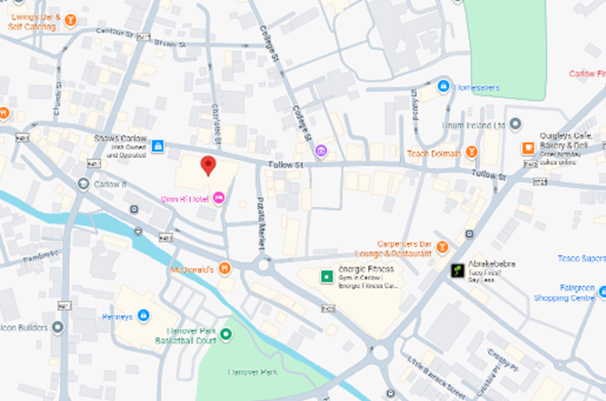

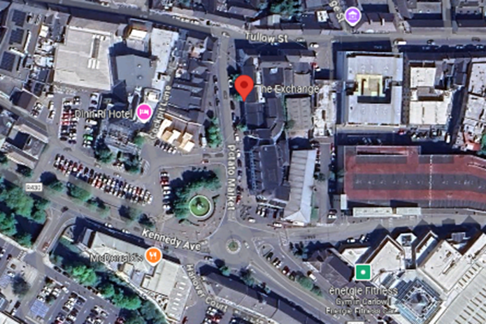

Map Number | 2
Area | Graiguecullen
Specific Location | Carlow Town Park
Municipal District | Carlow
Max. Number of Licences | 2

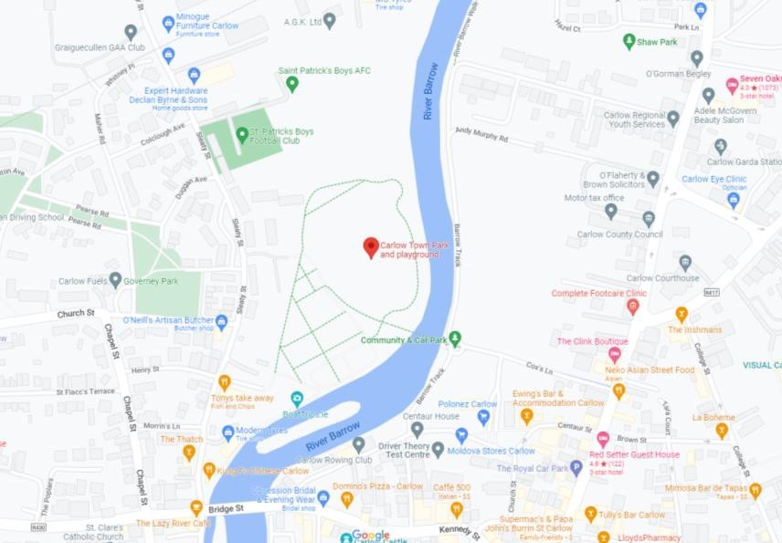
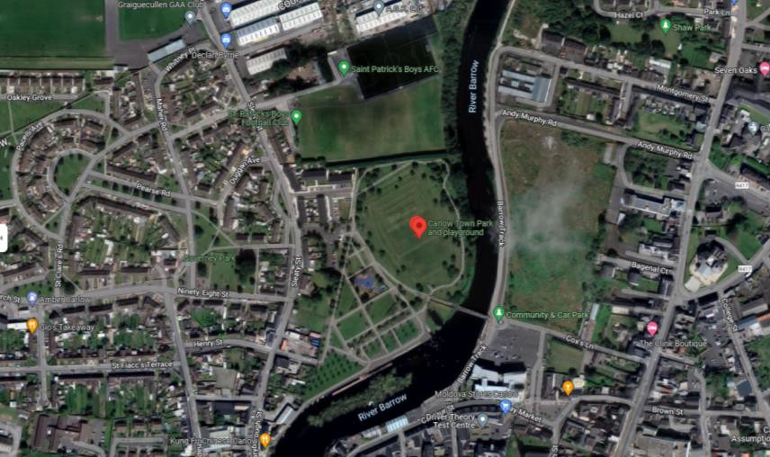

Map Number | 3
Area | Painestown
Specific Location | Oak Park Forest Park
Municipal District | Carlow
Max. Number of Licences | 1

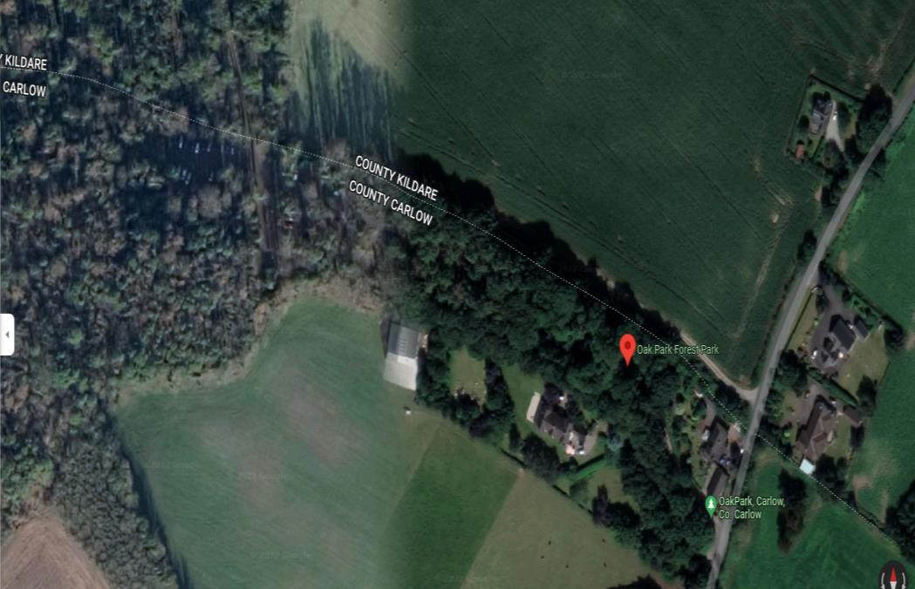
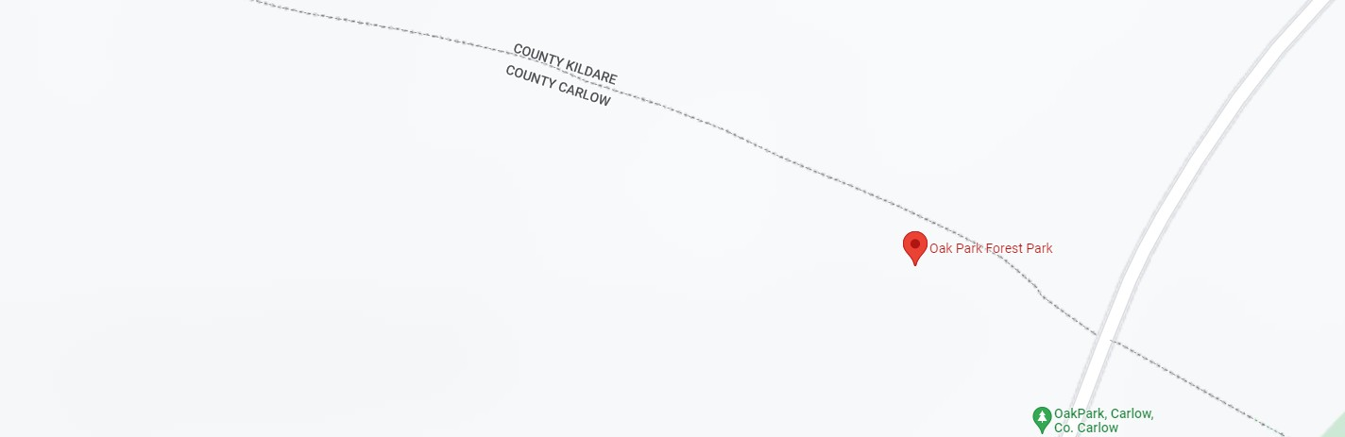

Map Number | 4
Area | Kernanstown
Specific Location | Brownshill Dolmen
Municipal District | Carlow
Max. Number of Licences | 1

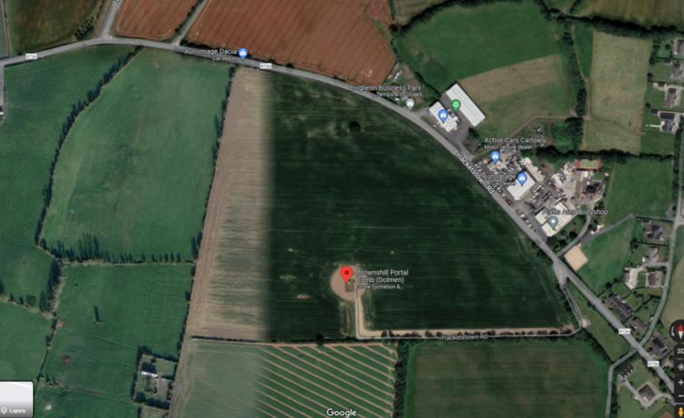

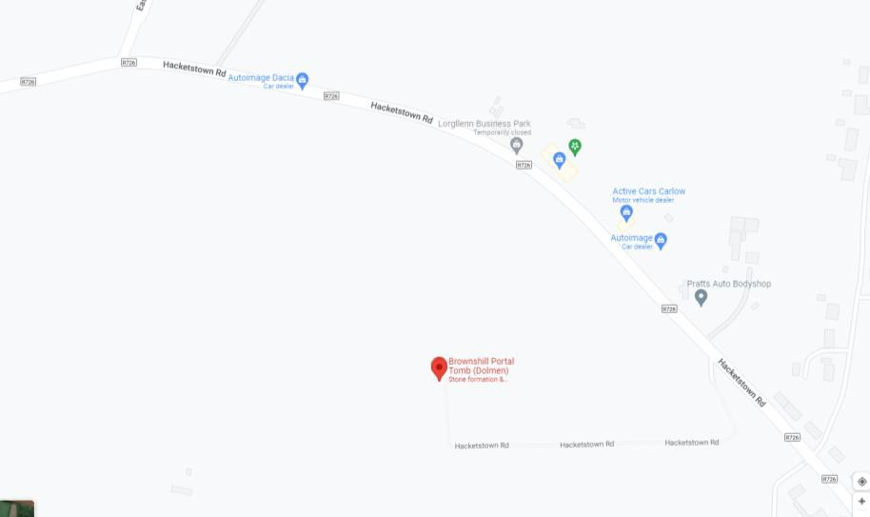

Appendix 2 – Application Form



Application Form for a Casual Trading Licence
Casual Trading Act, 1995

PLEASE READ THE NOTES OVERLEAF BEFORE COMPLETING THIS FORM
PLEASE COMPLETE IN BLOCK CAPITALS

(1) Name of Applicant: ____________________________________________________

(2) Business Name: ____________________________________________________

(3) Full Postal Address: ____________________________________________________
(Include your Eircode)
____________________________________________________

(4) Telephone Number: ____________________ (5) Occupation __________________

(6) (a) RSI No. (in the case of an individual): _____________________________________

(b) Tax Reference No. (in the case of a company): ________________________________

(7) If application is in the name of a limited company, the Company Registration Number, as
supplied by the Companies Registration Office: ___________________________________

(8) Public Liability Insurance

Please submit with your application to Carlow County Council evidence of Public Liability
insurance indemnifying Carlow County Council against any claims arising to a limit of
indemnity of €6.35 million, any one incident.

(9) Designated Trading Area at which it is intended to trade: ____________________________

(10) Indicate day(s) of week on which it is intended to trade:
______________________________________________________________________________

(11) Indicate proposed trading hours ________________________________________________

(12) First date on which it is intended to engage in casual trading: _________________________

(13) Description of goods to be sold: _______________________________________________
______________________________________________________________________________

If you were a holder of a previous Casual Trading Licence please quote the following:

Licence Number: __________________ Expiry date: ______________________

To the Local Authority Concerned:

I DECLARE:

1. that I have not been convicted of two or more offences under the Casual Trading Act, 1995,
within three years prior to the date on which I intend to commence casual trading

2. that the foregoing particulars are correct and I enclose a cheque/bank draft/money order/cash
or alternatively payment can be made by credit card over the phone by contacting the XXXX for €_________ being the fee fixed under bye-law by the local authority under Section 6 of the casual Trading Act, 1995.

Signature: _____________________ Date: _________________________

* Note (for information only)

Section 4(11) of the Casual Trading Act, 1995, provides that the local authority concerned shall notify the Minister for Social Welfare of the name and address of a person to whom a casual trading licence as granted and the conditions of the licence and section 4(2A) of the Casual Trading Act, 1995 (inserted by Section 141 of the Finance Act, 1996 (No. 9 of 1996)) provides that the local authority concerned shall notify the Revenue Commissioners of the name, address and tax reference number of a person to whom a casual trading licence was granted and the conditions of the licence. Section 13 of the Casual Trading Act, 1995 also provides that a local authority may establish and maintain the Register of Casual Trading Licences on computer. In such circumstances, personal date kept in the register is subject to the requirements of the Data Protection Act, 1988 (No. 25 of 1988 (including an individual’s right of access to and verification of date, where appropriate).

SCHEDULE

TO

CARLOW COUNTY COUNCIL CASUAL TRADING ACT 1995

BYE-LAWS

PART 2

The following are the fees in respect of Casual Trading Licences for the Municipal District of Carlow
An applicant for a Casual Trading Licence in a casual trading area shall pay a licence fee of €500 per annum except where casual trading takes place on more than one day per week then the licence fee shall be €500 plus €125 for each additional days casual trading per week. The maximum annual fee for a Casual Trading Licence will be €1,250 per Casual Trading Area.
An applicant for a Casual Trading Licence to trade at locations specified in the licence for a specified event or events pursuant to Section 4(l)(a)(iii) of the Act shall pay a licence fee of €50 per day.
The fees set out under this section may be updated annually by the Council in accordance with the Consumer Price Index.

Appendix 3 – Causal Trading Licence

Ref. Casual Trading Licence Number:

Casual Trading Act 1995

Casual Trading Licence – County of Carlow

- The County Council of the County of Carlow hereby grants to:

(Name & Address of Applicant)
(Tax Reference No.
a licence to engage in Casual Trading of the following goods:
(description of business)

In trading area (description) in the Casual Trading Area at (town) (Ref: Map no. of the Casual Trading Bye-laws for the Municipal District of _______________ in relation to the Control, Regulation, Supervision and Administration of Casual Trading made under the Casual Trading Act 1995) subject to full compliance with the Casual Trading Bye-Laws for the Municipal District of Carlow and subject to the following conditions:

- Trading may only be carried on between the hours of ___ a.m to ___ pm on the following days:
(days)

- All equipment, stalls, structures, barrows, carts, containers, litter, goods and articles shall be removed from the Causal Trading Area at the end of each day on which trading is permitted and no item is to be left in the Casual Trading area except between the permitted trading hours.

Page 1 of 2

- The vehicle used for trading should be parked in an agreed area in the trading area and should not interfere with traffic movement or nearby parking facilities. You must ensure that the display vehicle fits in the casual trading bay no. ___ and that it does not create any road safety hazard.

- Public Liability Insurance

Applications for licences must be accompanied by evidence of a current valid policy of insurance with a recognised insurance company and covering all activities associated with the purposes for which the Casual Trading Licence is to issue including all risks and perils to a minimum of €6,350,000 for any one incident, extending to provide an indemnity to the Council in respect of claims arising from the negligence of the Trader. Notice of termination of a policy shall render the said Casual Trading Licence null, void and of no effect and in which event the licence holder including servants and agents of the applicant shall forthwith cease to trade and render the area vacant and returned to the control of the Council.
(e) All litter generated by the trading activity shall be removed from the Casual Trading Area at the end of each trading day.

- This licence comes into force on the __________, and unless otherwise withdrawn will expire on the __________.

Signed: ____________________
Director of Services

Dated: ____________________

